**🔹VPC Flow logs**

**VPC Flow Logs capture and analyze network traffic in your AWS VPC, helping with security, troubleshooting, and monitoring.**

**🎯 Why Use It?**

**✅ Monitor Traffic – Track inbound & outbound flows  
✅ Enhance Security – Detect threats & anomalies  
✅ Troubleshoot Issues – Diagnose connectivity problems  
✅ Optimize Performance – Identify bottlenecks**

**🔗 How It Works?**

**1️ Enable Flow Logs (VPC, Subnet, or ENI)  
2️ Choose Destination – CloudWatch, S3, or Kinesis  
3️ Analyze Logs – Security, performance & cost insights**

**💰 Pricing – Pay for log storage & processing**

AWS: Transit Gateway

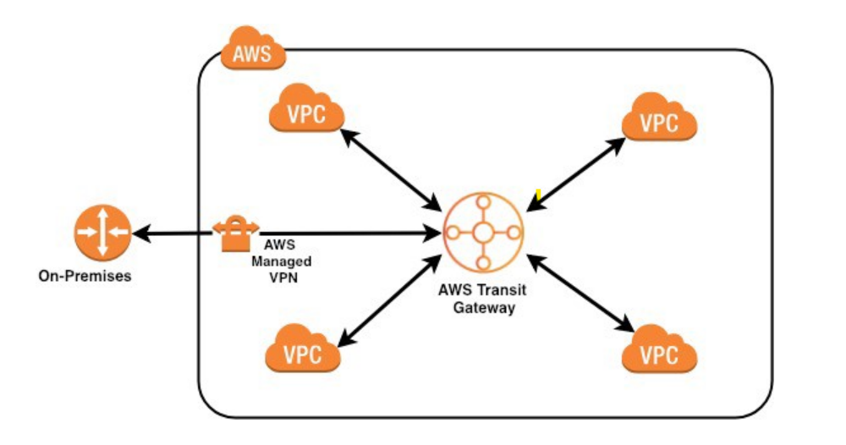

**🚀 AWS VPC Transit Gateway:**

**🔹 What is AWS Transit Gateway?**

AWS **Transit Gateway (TGW)** is a **high-speed, scalable hub** that connects **multiple VPCs, AWS accounts, and on-premises networks**—eliminating the complexity of VPC peering!

**🎯 Why Use It?**

✅ **Centralized Connectivity** – Connect thousands of VPCs seamlessly  
✅ **Hybrid Cloud Ready** – Link your on-prem data center via VPN/Direct Connect  
✅ **High Performance** – Uses AWS’s backbone for low-latency networking  
✅ **Simplified Routing** – One-to-many instead of complex peering links  
✅ **Multi-Region Expansion** – Connect AWS Regions effortlessly

**🔗 How It Works?**

1️. **Create a Transit Gateway** 🏗️  
2️. **Attach VPCs & On-Prem Networks** 🔗  
3️. **Define Routing Rules** 🛣️  
4️. **Secure & Monitor Traffic** 🔐

**💡 TGW vs. VPC Peering vs. Private Link**

| **Feature** | **Transit Gateway 🚀** | **VPC Peering 🔄** | **Private Link 🔌** |
| --- | --- | --- | --- |
| **Best for** | Multi-VPC & Hybrid Cloud | Direct VPC-to-VPC | Exposing services |
| **Scalability** | 1000s of VPCs | One-to-one | Service-based |
| **Cross-Region** | ✅ Yes | ✅ Yes | ✅ Yes |
| **Centralized Routing** | ✅ Yes | ❌ No | ❌ No |

**💰 Pricing Considerations**

🔹 **Pay per attachment & data transfer** (unlike free VPC Peering).  
🔹 **Optimized for large-scale AWS deployments.**

🔥 **When to Use?**  
✔️ Managing **multiple VPCs** efficiently  
✔️ Need **hybrid cloud connectivity**  
✔️ Want **scalable & secure network routing**

**🚀 AWS Direct Connect: High-Speed Cloud Networking!**

**🔹 What is AWS Direct Connect?**

AWS **Direct Connect (DX)** is a **dedicated, private network connection** from your **on-premises data center** to AWS—**bypassing the public internet** for **faster, more secure, and reliable connectivity**.

**🎯 Why Use It?**

✅ **Ultra-Low Latency** – Faster than VPN, ideal for real-time apps  
✅ **High Bandwidth** – Speeds from **50 Mbps to 100 Gbps**  
✅ **Better Security** – Private connection, no exposure to the internet  
✅ **Cost-Efficient** – Reduces outbound data transfer costs  
✅ **Hybrid Cloud Ready** – Seamlessly integrate on-prem & AWS

**🔗 How It Works?**

1️. **Create a Direct Connect Connection** 🏗️  
2️.**Choose a Direct Connect Location** 📍  
3. **Establish a Physical Link** 🔌  
4️. **Configure Virtual Interfaces (VIFs)** 🌐

**💡 DX vs. VPN vs. Transit Gateway**

| **Feature** | **Direct Connect 🚀** | **VPN 🌍** | **Transit Gateway 🔗** |
| --- | --- | --- | --- |
| **Best for** | High-speed private link | Secure internet connection | Multi-VPC connectivity |
| **Latency** | ⚡ Ultra-low | ⏳ Higher | 🔄 Varies |
| **Bandwidth** | 🌟 Up to 100 Gbps | 🌐 Up to 1.25 Gbps | 🚀 Scalable |
| **Security** | 🔒 Private Network | 🔐 Encrypted over the internet | 🔄 Managed routing |

**💰 Pricing Considerations**

💲 **Charged per port-hour & data transfer** (cheaper than internet-based transfers).

🔥 **When to Use?**  
✔️ You need **consistent, high-speed AWS connectivity**  
✔️ You want **lower network costs & higher security**  
✔️ Your workloads demand **low-latency hybrid cloud networking**